NETFLIX SQL PROJECT
- What is the total number of 'Movies' and 'TV Shows' on Netflix?
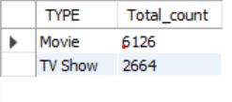
- Which country has produced the most content (Movies + TV Shows) on Netflix? List the top 5 countries
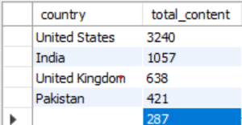

- Retrieve a list of all movies and TV shows released in the year 2020.
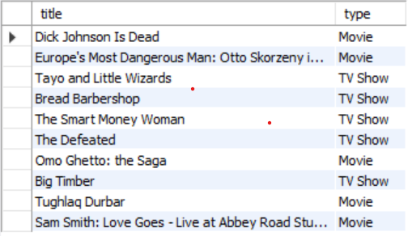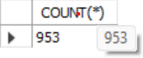

- What are the titles of all movies directed by 'Kirsten Johnson'?
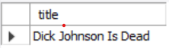

5. Which content rating is the most common on Netflix? (Count of titles by
rating).
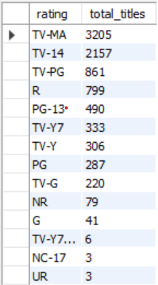

6.Find the list of all 'TV Shows' that have 5 or more seasons.
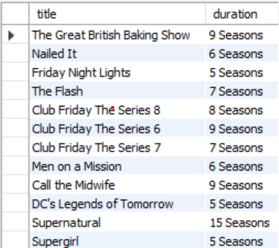

7. List all the movies produced in 'India' that belong to the 'Comedies' category.
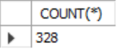
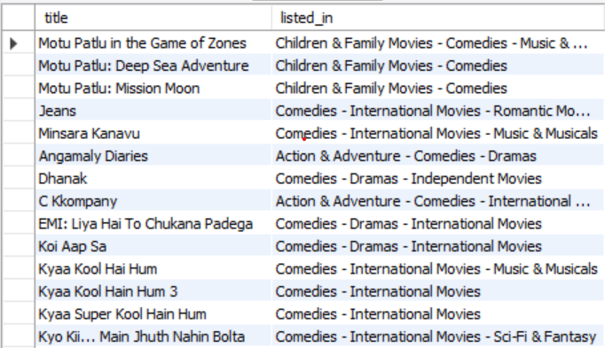

8. How many new shows/movies were released each year? Sort the results in
descending order of the release year.
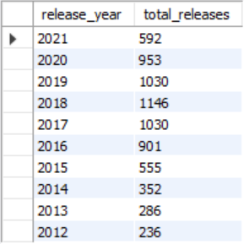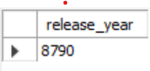

9. Who are the top 5 directors with the highest number of directed movies
(excluding 'Not Given')?

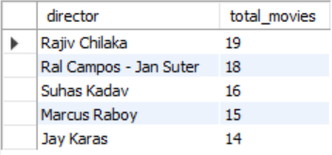

10. In which year did Netflix add the highest amount of content to its platform?


11. Which are the 5 oldest movies released in India on Netflix?
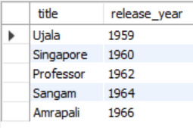
12. Find the titles of all movies listed as 'Documentaries' that were released
after the year 2015.
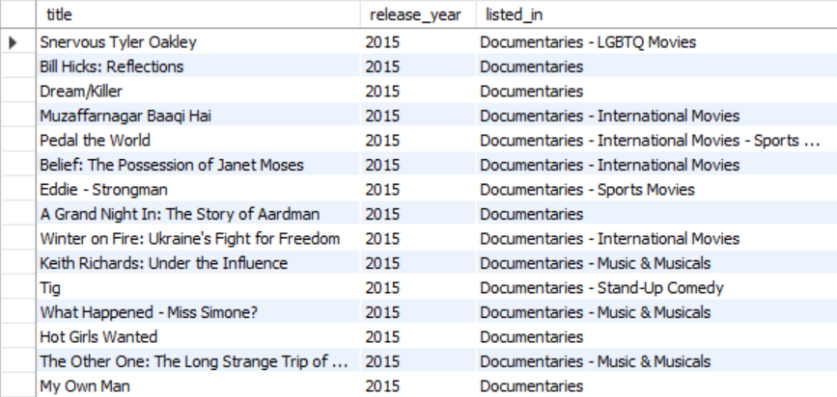

13. Which movie has the longest duration in minutes on Netflix?



14. What is the most recently released movie for each country?
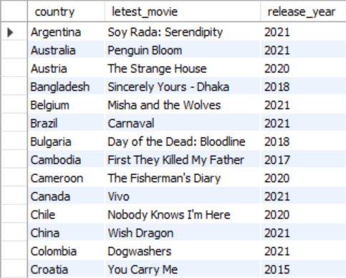

15. Identify the release years in which more than 50 movies from India were
released.

